H.T No
Regulations:
A15

Sreenidhi Institute of Science and Technology
(An Autonomous Institution)
Code No: 5H213 Date: 14-Mar-2023 (AN)

B.Tech I-Year II- Semester External Examination, March/April-2023 (Supplementary)
ENGINEERING MATHEMATICS – II (Common to All except BT)

Time: 3 Hours Max.Marks:75 Note: a) No additional answer sheets will be provided.
b) All sub-parts of a question must be answered at one place only, otherwise it will not be valued.
c) Missing data can be assumed suitably.

Bloom's Cognitive Levels of Learning (BCLL)
Remember | L1 | Apply | L3 | Evaluate | L5
Understand | L2 | Analyze | L4 | Create | L6

Part - A Max.Marks:25

Answer all QUESTIONS.
 |  | BCLL | CO(s) | Marks
1 | Determine the value of such that the rank of the matrix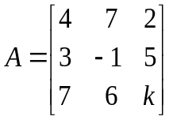 is | L2 | CO1 | [2M]
2 | Find the sum and product of the Eigen values of the matrix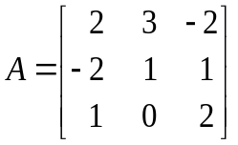 | L2 | CO2 | [2M]
3 | Form the partial differential equations by eliminating the arbitrary constants from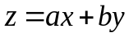 | L3 | CO3 | [2M]
4 | Find the Laplace transform of 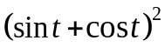 | L3 | CO4 | [2M]
5 | Find the inverse 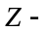transform of 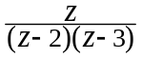 | L2 | CO5 | [2M]
6 | Find the Fourier cosine transform of the function 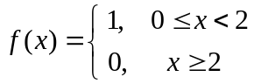 | L2 | CO6 | [3M]
7 | Find eigen values of the matrix 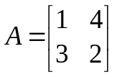 | L3 | CO1 | [3M]
8 | Classify the PDE: 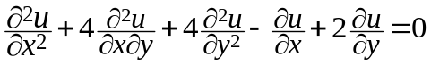 | L3 | CO3 | [3M]
9 | Show that 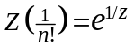 | L2 | CO5 | [3M]
10 | Find the Fourier coefficient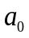for the function 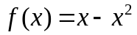in 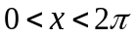 | L2 | CO6 | [3M]

Part – B Max.Marks:50
ANSWER ANY FIVE QUESTIONS. EACH QUESTION CARRIES 10 MARKS.

 |  |  | BCLL | CO(s) | Marks
11. | a) | Find the rank of the matrix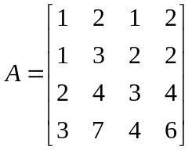by reducing it into echelon form | L3 | CO1 | [5M]
 | b) | Find the inverse of the matrix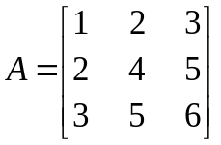 using Gauss - Jordan method | L3 | CO1 | [5M]
12. |  | Reduce the matrix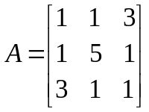to the diagonal form | L3 | CO2 | [10M]
13. | a) | Form the partial differential equation by eliminating the arbitrary function from 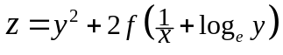 | L4 | CO3 | [5M]
 | b) | Solve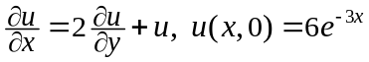 by the method of separation of variables | L3 | CO3 | [5M]
14. | a) | Evaluate 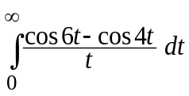 | L3 | CO4 | [5M]
 | b) | Apply convolution theorem to evaluate 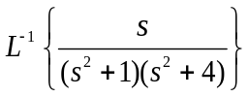 | L3 | CO4 | [5M]
15. |  | Solve using Z-transforms | L3 | CO5 | [10M]
16. |  | Find a Fourier series to represent 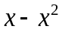 in 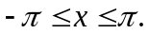 Hence show that 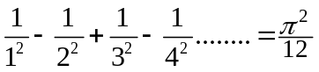 | L3 | CO6 | [10M]
17. | a) | Solve by Gauss elimination method | L3 | CO1 | [5M]
 | b) | Verify Cayley-Hamilton theorem for the matrix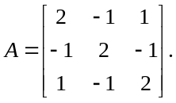Hence find 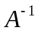 | L4 | CO2 | [5M]
18. | a) | Evaluate 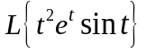 | L4 | CO4 | [5M]
 | b) | Find the Fourier transform of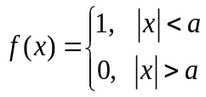 | L3 | CO5 | [5M]

-- 00 -- 00 –

